- 2 cups of All Purpose flour
- 1 teaspoon of baking powder
- 1 Tablespoon of Sugar
- 1/2 Teaspoon of salt
- 1 egg
- 1 Tablespoon of butter (melted and already cool)
- About 3/4 cup of warm water * (See note)
- 1 teaspoon of vanilla essence ** (See note)
- About 2 cups of vegetable oil to fry the Buñuelos
- Sugar to sprinkle
1. In a large bowl mix flour, baking powder, 1 Tablespoon of sugar and 1/2 teaspoon of salt.
2. Form a well in the center and add the egg, melted butter and vanilla. Mix until mixture resembles a coarse meal. Slowly add the water a tablespoon at a time, mixing and kneading until you have a soft and smooth dough. This will take less than 5 minutes. Cover the dough with a kitchen towel and let it rest for 30 minutes.
3. While the dough is resting prepare your working area with a rolling pin, a large dish with paper towel or open paper bags, extra flour for rolling the circles, a large frying pan with the vegetable oil ready for the moment you start frying the Buñuelos.
4. Divide the dough in 12 small balls and cover. Heat 3/4 inch of oil the large frying pan
5. Place one of the dough balls in your already floured working surface and stretch with your rolling pin. Roll out each ball to form a circle as thin as possible without breaking the dough.
6. To give that extra stretching to the Buñuelo, place in the inverted bowl or clay pot covered with the pastry towel and pull the edges very gentle. The Buñuelo should be thin almost transparent.
7. Fry the Buñuelos in very hot oil until they are golden and crispy. This step will take a few seconds. Place the Buñuelos on plate covered with paper towels to drain the excess oil. Serve warm or at room temperature and sprinkle with sugar. If you do not sprinkle the sugar right away they can still be nice and crispy for another day and just add the sugar at serving time. If you prefer to serve them warm, place them in you oven in a low setting for 5 minutes. Now, we need some hot chocolate to go alone with the Buñuelos.

1. In a large bowl mix flour, baking powder, 1 Tablespoon of sugar and 1/2 teaspoon of salt.
2. Form a well in the center and add the egg, melted butter and vanilla. Mix until mixture resembles a coarse meal. Slowly add the water a tablespoon at a time, mixing and kneading until you have a soft and smooth dough. This will take less than 5 minutes. Cover the dough with a kitchen towel and let it rest for 30 minutes.
3. While the dough is resting prepare your working area with a rolling pin, a large dish with paper towel or open paper bags, extra flour for rolling the circles, a large frying pan with the vegetable oil ready for the moment you start frying the Buñuelos.
4. Divide the dough in 12 small balls and cover. Heat 3/4 inch of oil the large frying pan
5. Place one of the dough balls in your already floured working surface and stretch with your rolling pin. Roll out each ball to form a circle as thin as possible without breaking the dough.
6. To give that extra stretching to the Buñuelo, place in the inverted bowl or clay pot covered with the pastry towel and pull the edges very gentle. The Buñuelo should be thin almost transparent.
7. Fry the Buñuelos in very hot oil until they are golden and crispy. This step will take a few seconds. Place the Buñuelos on plate covered with paper towels to drain the excess oil. Serve warm or at room temperature and sprinkle with sugar. If you do not sprinkle the sugar right away they can still be nice and crispy for another day and just add the sugar at serving time. If you prefer to serve them warm, place them in you oven in a low setting for 5 minutes. Now, we need some hot chocolate to go alone with the Buñuelos.

-2 cups of All Purpose flour
-1 teaspoon of baking powder
-1 Tablespoon of Sugar
-1/2 Teaspoon of salt
-1 egg
-1 Tablespoon of butter (melted and already cool)
-About 3/4 cup of warm water * (See note)
-1 teaspoon of vanilla essence ** (See note)
-About 2 cups of vegetable oil to fry the Buñuelos
-Sugar to sprinkle

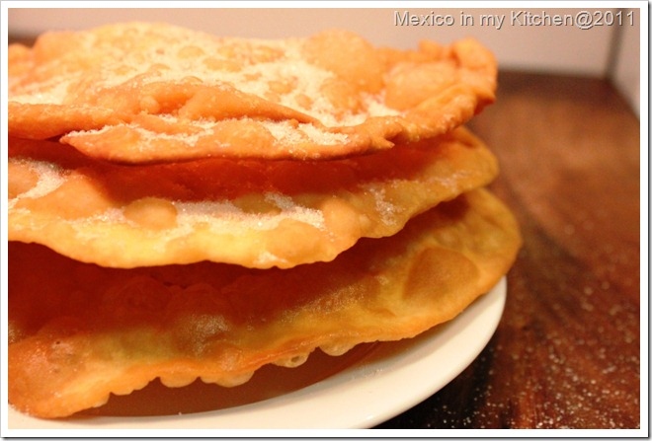

Como hacer Buñuelos Mexicanos

